Scenes that Inspire Awe 2

Now that we have found a picture of nature that is inspiring to us your task is to now compose a poem that describes this natural scene and what you feel when you see it. Your poem should include 6 or more poetic devices (such as metaphor, simile, alliteration…) and you may repeat the poetic device multiple times within your poem.

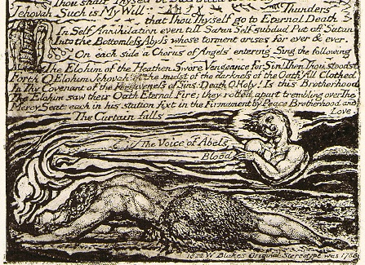

Scenes That Inspire Awe 3
Now that we have your poem your task is to, like William Blake, create an artistic piece to accompany your poem. This can take the form of a drawing, a painting, a slideshow, a collage or a video that will accompany your poem. This visual production is meant to be creative and will be marked on your creativity and originality.

