Scenes that Inspire Awe
This assignment is intended to be creative and challenges you to think critically about your surroundings and what you take for granted in nature. Your presentation should reveal the details and the vibrancy that nature offers but that we are not fully conscious of. Please present your image that inspires you and give a detailed explanation that articulates exactly what you find awe inspiring and relevant to nature. Please also send a digital copy of the art to me and save it as a JPEG so that I can print out the image and display it all year round in the classroom. This way the image or work of art can inspire you year-round. In your presentation, please describe your scene with 3 poetic devices.

This would be my selection for this assignment:

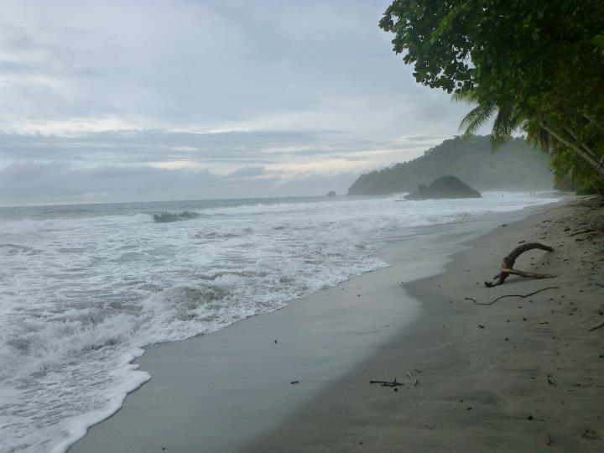

Poetic Devices:

1:

2:

3:

